 Writing Curriculum Plan Year EYFS Year A
Year A
Overview:
Year A | Autumn 1 |  |  |  |  | Autumn 2 |  |  |  | Spring 1 |  |  |  | Spring 2 |  |  |  |  | Summer 1 |  |  |  |  | Summer 2
 | Class Text: Year 1 and 2 |  |  |  |  |  |  |  |  | Class Text: Year 1 and 2 |  |  |  |  |  |  |  |  | Class Text: Year 1 and 2
Progression of Year 1 and 2 Core Texts | Sylvia and Bird |  | My Day at the Zoo |  |  | Zim Zam Zoom |  | How to catch Santa |  | Little Red Riding Hood |  | Now you know Science – Hot and Cold |  | Mixed up Fairy Tales |  |  | The Slime Book |  | Mrs Armitage and the Big Wave |  | Creature Features |  |  | A First Poetry Book |  | Traction Man is Here
 | EYFS Texts |  |  |  |  |  |  |  |  | EYFS Texts |  |  |  |  |  |  |  |  | EYFS Texts
Progression of EYFS Core Texts |  | 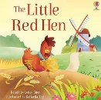 |  | 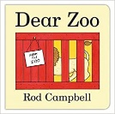 | 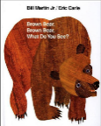 |  | 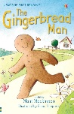 |  | 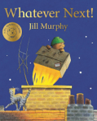 | 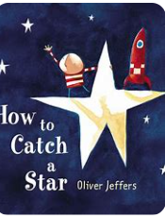 | 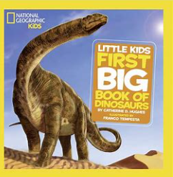 |  | 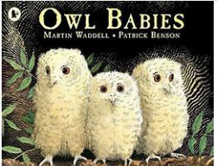 |  | 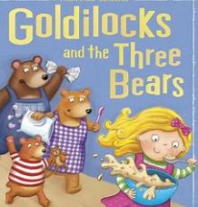 | 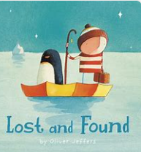 |  | 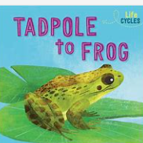 | 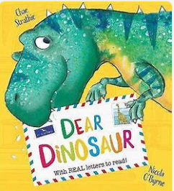 | 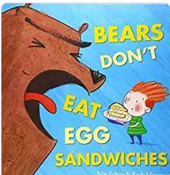 |  | 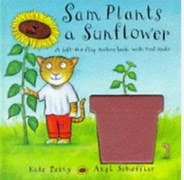 | 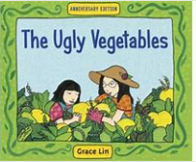 |  | 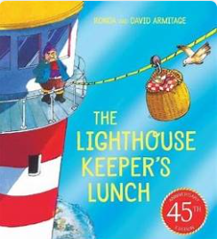 |  | 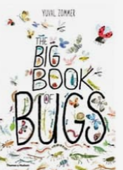
Literacy
Writing ELG | - Write recognisable letters, most of which are correctly formed.  - Spell words by identifying sounds in them and representing the sounds with a letter or letters.  - Write simple phrases and sentences that can be read by others.
Comprehension ELG | - Demonstrate understanding of what has been read to them by retelling stories and narratives using their own words and recently introduced vocabulary.  - Anticipate (where appropriate) key events in stories.  - Use and understand recently introduced vocabulary during discussions about stories, non-fiction, rhymes and poems and during role play.
Word Reading ELG | - Say a sound for each letter in the alphabet and at least 10 digraphs.  - Read words consistent with their phonic knowledge by sound-blending.  - Read aloud simple sentences and books that are consistent with their phonic knowledge, including some common exception words
Communication and Language
Listening, attention and understanding ELG | - Listen attentively and respond to what they hear with relevant questions, comments and actions when being read to and during whole class discussions and small group interactions.  - Make comments about what they have heard and ask questions to clarify their understanding.  - Hold conversation when engaged in back-and-forth exchanges with their teacher and peers.
Speaking ELG | - Participate in small group, class and one-to-one discussions, offering their own ideas, using recently introduced vocabulary.  - Offer explanations for why things might happen, making use of recently introduced vocabulary from stories, non-fiction, rhymes and poems when appropriate.  - Express their ideas and feelings about their experiences using full sentences, including use of past, present and future tenses and making use of conjunctions, with modelling and support from their teacher.
Physical Development
Finer Motor Skills ELG | - Hold a pencil effectively in preparation for fluent writing – using the tripod grip in almost all cases.  - Use a range of small tools, including scissors, paintbrushes and cutlery.  - Begin to show accuracy and care when drawing.

